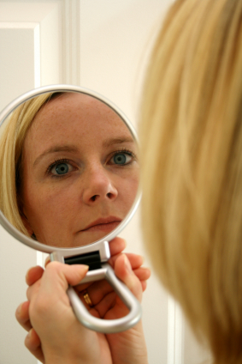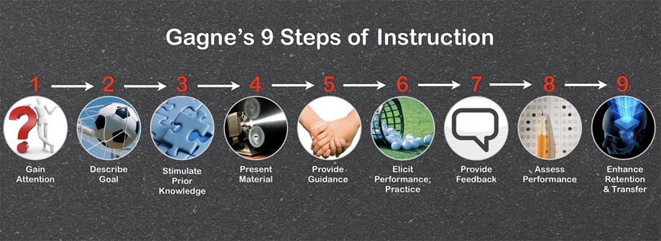**Gagne’s Nine Steps of Instruction**

**Sokol’s 10th**

**Time for Reflection**

**-Q/A (5 min)**

**-+/- of this session (give me feedback)**

**(7 min)**

**-Use Gagne’s 9 events of instruction as an organizing framework for your Grand Rounds**

**-Create a focused Grand Rounds presentation with a few clear and succinct learning objectives that meet learners' needs**

**-Implement various techniques for creating interactive learning sessions that play to the different ways people learn**

**-Provide further reading on learning objectives and bloom’s taxonomy**

**-Participants now tasked with using materials to present Grand Rounds**

**I ask questions throughout the presentation about *my* use of Gagne as I present on Gagne to assess for understanding**

**-Discussion part of activity above (Have one person share what they wrote for Gagne’s 9 events and give feedback in front of larger group; invite others to comment)**

**Several activities in between me talking**

**-discussion on +/- aspects of presentation**

**-individual activity + discuss—writing learning objectives and gaining attention**

**-individual activity + discuss—content, how to provide guidance, elicit performance, time allocation (15 more mins)**

**-Gagne’s 9 events framework + provide this example**

**-Checklist handout**

**-Gagne’s 9 events**

**-Core principles around presentation of content (less is more, use speaker notes, time allocation, keep repetitive, use stories, keep interactive, practice ahead of time) (25 mins)**

**Reflection and group discussion activity of +/- aspects of presentations participants have previously been part of**

**(5 mins)**

**-Funny video (pointing out overreliance on powerpoint)**

**-Me reading my slides about myself (point- we should not be reading slides) (6 mins)**