August 9, 2019

Stacy Potts, MD

Chair,

ACGME Family Medicine

Milestones Version 2.0 Task Force

Dear Dr. Potts:

On behalf of the Council of Academic Family Medicine (CAFM), we write to submit comments to a specific section of the Family Medicine Draft 2.0 Milestones, Systems-Based Practice 4: Advocacy. CAFM includes the Society of Teachers of Family Medicine, the Association of Departments of Family Medicine, the Association of Family Medicine Residency Directors, and the North American Primary Care Research Group.

We submitted (as part of the Academic Family Medicine Advocacy Committee (AFMAC)) a number of suggestions regarding strengthening the development of advocacy skills on the part of family medicine residents. We are grateful that the Task Force has included several of our suggestions and feel this version (Systems-Based Practice 4: Advocacy) is much better than the previous one. We do however have several recommendations that we believe would strengthen the document and share them with you here. Our recommendations below refer to both the actual milestones draft document as well as the supplemental guide, where we include recommendations for the examples and the Notes or Resources sections.

We strongly urge you to move learning how to access advocacy tools and other resources from level 4 to level 3. Since level 3 is “where the resident continues to advance and demonstrate additional milestones; and consistently demonstrates the majority of milestones for residency”, we think this is where the tools to influence stakeholders should be learned for two reasons. One, it’s hard to know “how to describe how stakeholders influence and patients are affected by health policy” without understanding the tools available to influence health policy. Two, upon learning this in level 3, the resident can then practice and implement using these tools prior to graduation – making taking action and applying skills and knowledge as the level 4 Milestone. Our view is that these skills should be learned by every resident earlier in their residency so that they can be practiced and developed by the time the resident graduates.

**Recommended Changes:**

**Level 3:** “Describes how stakeholders influence and patients are affected by health policy at the local, state and federal level and know how to access advocacy tools and other resources needed to achieve (or prevent a deleterious) policy change.”

**Examples for Level 3:** move the ones from Level 4 (complete online advocacy modules and respond to advocacy email alerts) up to level 3, in addition to the examples already included under level 3.

**Level 4:** “Chooses and Implements an advocacy tool to communicate with a policy maker about an issue of importance to individual or community health.”

**Examples for Level 4**: move two examples from level 5, the first and third bullets (“contacts legislators on matters of importance to family medicine,” and “attends advocacy days at the state capitol to speak with legislators”) up to level 4. Additional examples such as communicate with someone in a local agency, write an op-ed for a local newspaper, conduct a visit to a legislator, etc. might be included here as well.

**Level 5:** Milestone can remain the same as we understand that this process would typically happen after residency, and not necessarily by all family physicians in practice.

**Examples for Level 5**: Add to the examples under Level 5, “conducts multiple visits or contacts with a legislator.”

**Notes or Resources:** Under Notes or Resources in the Supplemental Guide we recommend including the link to the STFM free online advocacy modules. The term “online advocacy modules” is used throughout the document – it would make sense to include a link to them.

The modules can be found at <https://www.stfm.org/facultydevelopment/onlinecourses/advocacycourse/overview/>

In addition, we recommend you include the STFM advocacy website link along with the AAFP’s and others. It is: <https://www.stfm.org/about/advocacy/resourcesandissues/>

Once again, we appreciate the attention the Task Force has given to advocacy and are pleased with much of what has been included. We appreciate the opportunity to recommend further changes to the draft Family Medicine Milestones, Version 2.0.

Sincerely,



Freddy Chen, MD, MPH

President

Society of Teachers of Family Medicine



Deborah S Clements, MD

President

Association of Family Medicine Residency Directors

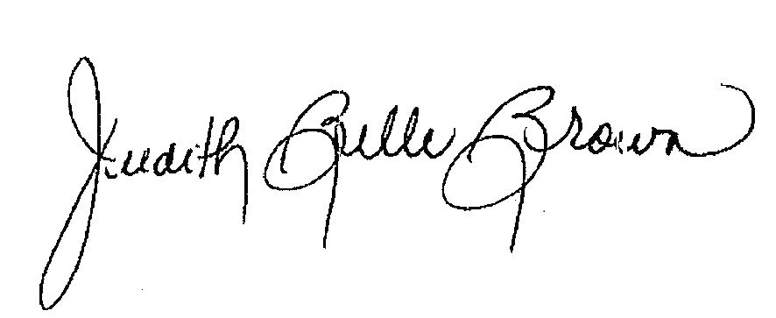

Judith Belle Brown, PhD

President

North American Primary Care Research Group



Allen Perkins, MD, MPH

President

Association of Departments of Family Medicine