

FMLC Report: February 2024

North American Primary Care Research Group (NAPCRG)

Below are updates on: I) Artificial intelligence and II) Research:

**I. Artificial Intelligence**

NAPCRG is still determining its focus in AI, but there have been a couple of notable areas of interest:

**AI Bootcamp**: With the generous sponsorship of the Gordon and Betty Moore Foundation and support from the American Board of Family Medicine Foundation, HEA3RT celebrated a landmark moment at last year's NAPCRG annual meeting — a sold-out Artificial Intelligence (AI) Bootcamp (held on Monday, October 30, 2023) that drew a diverse crowd of over 115 primary care researchers, clinicians, and healthcare professionals. Each attendee arrived with a shared objective: to delve into the vast potential that AI holds for primary care.

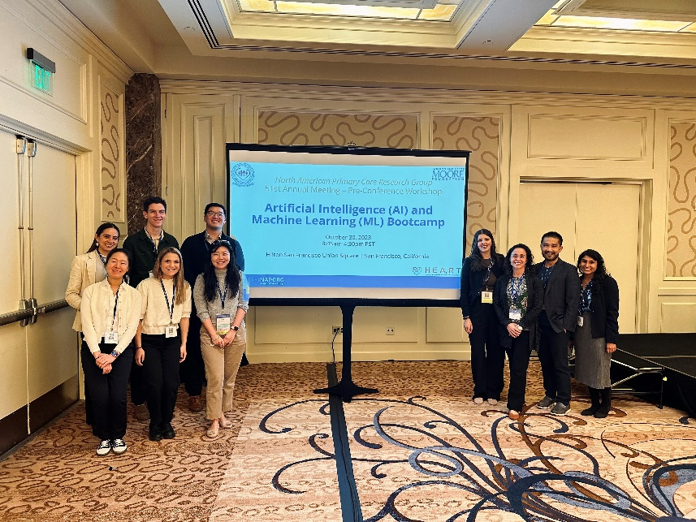**

The day began with a series of expert-led discussions. Google scientist Yun Liu skillfully illuminated attendees on the foundational elements of AI and machine learning (ML), making complex concepts accessible to a non-technical audience. Mark Sendak, from Duke Health, then offered an inspiring look into how Duke is approaching AI/ML implementation as well as a frank perspective on the challenges and 'messiness' inherent in implementing AI/ML in real-world settings. The morning was rounded out by Marti Health, Chief Medical Officer Irene Dankwa-Mullan’s thought-provoking exploration of bias and health equity within AI/ML applications, setting a high bar for the rigor that be expected and employed to safeguard against algorithmic and implementation bias across the ML development lifecycle.

Transitioning from theory to application, the afternoon showcased the Grant Generating Project fellows, who presented their AI/ML research proposals to a panel of expert clinicians, researchers, and community leaders. The interactive Q&A that followed bridged the gap between the concepts attendees learned in the morning lectures and practical application, embodying the workshop’s intent to inspire actionable insights and catalyze AI/ML research and thought leadership within primary care.

The dynamic discussions and insightful presentations will extend well beyond the day as every presentation, discussion, and exchange were captured through audio and video recordings, creating a valuable repository for the creation of more broadly accessible education modules. The content will be instrumental in developing an AI/ML curriculum tailored to front-line providers, equipping providers with the knowledge and tools necessary to engage in AI/ML research and translation from “code to bedside”. As we look to the future, these resources will be pivotal in nurturing an informed primary care workforce, ready to harness the advantages of AI/ML and shape the future of AI/ML for healthcare.

**Endorsement of Starfield Summit on AI**: The NAPCRG Executive Committee endorsed Dr. Wayne Altman’s request to hold a Starfield Summit on AI and Family Medicine. Dr. Altman has a working group of about ten people from all over the US who have been working on AI and Family Medicine.

They plan to delve deep into this subject matter to explore several different aspects of AI in Family Medicine:  
  
1. How Family Medicine can be cutting edge with AI and how to bring AI into the trenches with practicing family doctors across the country.

2. How to use AI to decrease administrative burden in Family Medicine.

3. How to research the use of AI and how it impacts the practice of Family Medicine and the patient-physician relationship.

**II. Research**

As an organization, NAPCRG is dedicated to nurturing primary care researchers. Therefore, NAPCRG’s work is focused on research. However, here are a couple of significant updates:

**NAPCRG Awarded Generous Financial Support for Key Initiatives:**

In May 2024, NAPCRG was honored to receive two substantial financial awards totaling

$959,000 from the American Board of Family Medicine (ABFM) Foundation. These awards are

aimed at advancing pivotal primary care research initiatives.

The first award, amounting to $400,000 over four years, is designated for the creation of a

comprehensive NAPCRG training program for primary care researchers. This initiative will

involve curating and supporting existing training programs, as well as developing new ones. As

outlined in the National Strategic Plan for Primary Care Research, the objectives include

developing a database of research training programs, enhancing and expanding research

pathways for medical students, residents, and physicians, promoting a culture of curiosity, and

utilizing distinct methodologies. The ultimate goals are to engage more primary care providers in

practice improvement through research, increase the impact of primary care research, offer year-

round workforce training opportunities (beyond the NAPCRG Annual Meeting), and create a

new source of revenue for NAPCRG. Leading this initiative is Hannah Juarez, LSCSW, who

began her role as part-time Training and Program Project Manager at NAPCRG on July 1.

The second award, totaling $559,000, supports the hiring of a full-time Research Coordinator.

This individual will provide administrative responsibility for advancing the fifteen objectives of

the National Family Medicine Research Strategic Plan over its five-year duration. The journey to

this strategic plan culminated in the Family Medicine Research Summit, held on October 30,

2023, at the Hilton San Francisco Union Square Hotel during the 51st NAPCRG Annual

Meeting. The Summit marked a historic day for family medicine, gathering over 140 visionaries,

innovators, and leaders in the field to develop a research-focused strategic plan for the discipline

in the United States.

Finalized in August 2023, the National Family Medicine Strategic Plan for Research includes

three strategic priorities: Pathways/Mentorship, Funding and Advocacy, and Infrastructure. Each

priority has one goal and five objectives, making a total of 15 objectives. The ABFM

Foundation’s funding enables the hiring of a Research Coordinator who will work closely with

Irfan Asif, MD, the lead champion for the plan and the plan’s implementation. The Research Coordinator position has recently been posted, with interviews and hiring decisions expected in the coming weeks.

These generous awards from the ABFM Foundation represent a significant step forward in

enhancing primary care research and training, underscoring the commitment to advancing the

discipline of family medicine.

**Strategic Planning**: NAPCRG’s Board of Directors has launched a strategic planning process using a process called **foresight.** Foresight was developed by the American Society of Association Executives (ASAE) and is a systematic, multi-stepped process for discerning, analyzing, and acting on potential futures. By asking the following three questions, foresight allows an association’s board of directors to shape the organization’s future by thinking about plausible futures. In addition, foresight helps a board decide what they might do today to move an organization toward some of those preferred futures.

The three questions and their desired outcome include:

* What do we think will happen? Our expected future.
* What might happen instead? Alternative or plausible futures.
* What do we want to happen? Our preferred future.

An easy way to get the essence of foresight is to ask oneself: In the year 2015 if I knew there would be a pandemic in the year 2020, what might I do to start preparing?

By using a foresight approach to the planning process, the Board of Directors will be able to identify challenges they see in the future and will be able to shape the direction they will take for successful progress toward NAPCRG’s vision. In addition, the model the Consultants developed that integrates foresight into strategic planning is summarized on one page, making it easier to communicate to NAPCRG members. This allows the Board to build consensus around the direction they plan to take.

The NAPCRG strategic planning process is being facilitated by Governance Directions and will include a full board and staff retreat scheduled on November 18, 2024, in Quebec City at the beginning of the NAPCRG Annual Meeting. A new, three-year strategic plan will be presented to the NAPCRG Board of Directors for approval in May 2025.