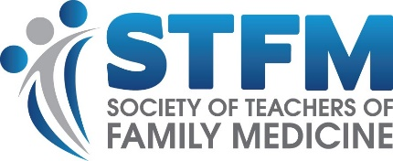

STFM Medical Student Educators Development Institute (MSEDI)

Letter of Support for MSEDI Applicant

All MSEDI Fellows will be expected to:
- Be a current member of STFM during their time in the Institute
- Attend in-person workshops
  - Saturday, May 3, 2025 from 8am-5pm - Workshop during the preconference day at the STFM Annual Spring Conference (conference registration included)
  - Thursday, January 29, 2026 from 8am-5pm - Workshop during the preconference day of the STFM Conference on Medical Student Education (conference registration included)
- Participate in monthly virtual meetings with their mentor between in-person workshops
- Submission to the 2027 Conference on Medical Student Education (conference registration NOT included)

Letter of Support
I acknowledge that _____________________________________will benefit from the STFM Medical Student Educators Development Institute. I support this faculty member’s participation and encourage their success.
Please provide any additional comments about your faculty member’s participation or your expectations (optional) ________________________________________________________________________________________________________________________________________________________

_________________________________ ______________________________
Department Chair or Designee Name Signature

