Question: How do I edit my demographic info
- Log in to your STFM account.
- After successfully logging in, you should see this screen:
- 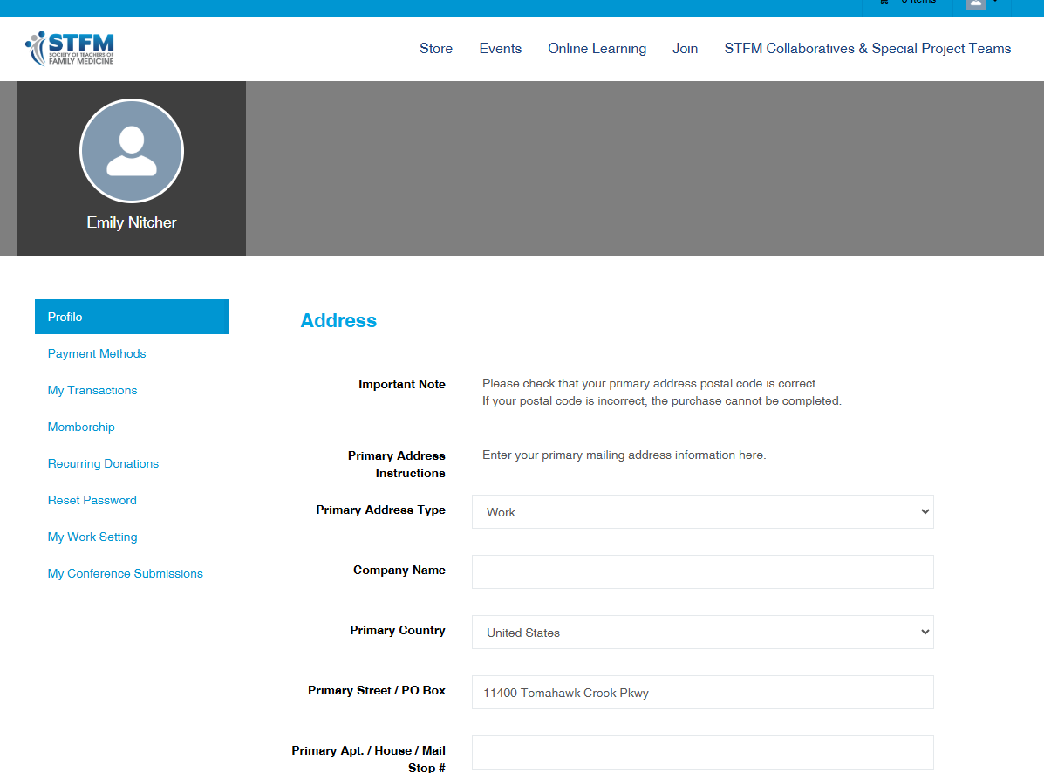
- Scroll down to the information fields you wish to update
- Scroll to the bottome of the page and click “Save Profile Information”
Question: How do i edit my profile?
- See previous answer
Question: What are the requirements for becoming a member of STFM?
- There are 10 membership types each designed for a particular fam med ed role.
  - Physician membership: Any physician who is in a teaching position or actively involved in the organization, administration, or promotion of family medicine
  - Other family medicine educator membership: Any individual, who is not a physician, who is in a teaching position or is actively involved in the organization, administration, or promotion of family medicine. Examples include pharmacists, behavioral scientists, physician assistants, researchers, social workers, etc.
  - Associate membership: Faculty (employed and community) who devote no more than 10 hours per week or 3 months per year to teaching
  - Coordinator membership: Any individual who is in a coordinator position (examples include medical student education coordinators, residency coordinators, clerkship coordinators)
  - International membership: Any individual who either holds a teaching position or is actively involved in the organization, administration, or promotion of family medicine who resides outside the United States or Canada.
  - Student membership: Any individual who is a medical (MD or DO) student
  - Resident membership: Any individual who is in residency
  - Fellow membership: Any individual who is currently participating in a fellowship program
  - Emeritus membership: Any individual, retired or age 70 or over, who has been an STFM member for 10 or more years
  - Lifetime membership: Any individual who is age 60+. This category provides full membership — for a lifetime — with voting rights and is a fantastic way to honor retiring faculty for their service.
Question: How can I tell if I have a membership?
- Look in your inbox(es) for any membership and/or marketing emails from STFM
- Check your email(s) for a membership receipt (example below)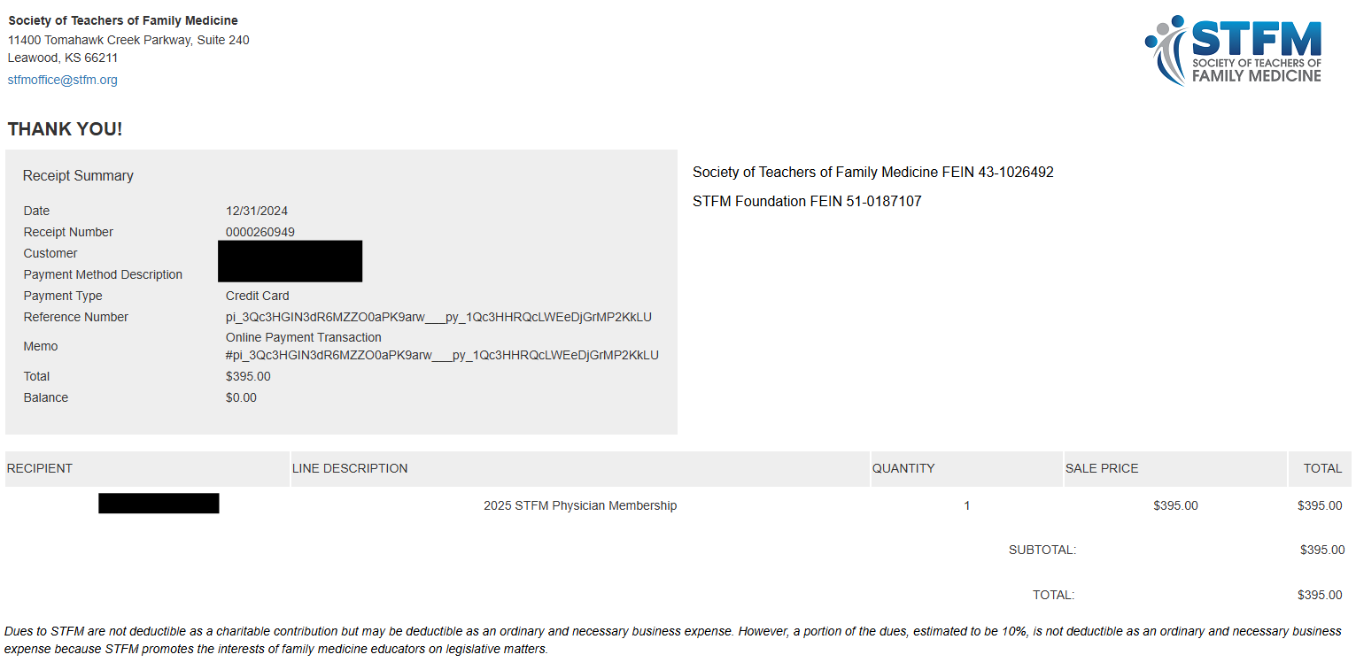
- If you believe your membership was purchased by your institution, confirm with your admin or program manager, or by emailing membership engagement manager, Emily Nitcher at enitcher@stfm.org
Question: How many CME credits do I need to complete before my membership renewal is due, and are there any specific CME credit requirements for my membership type?
- There are no CME credits required to have and maintain STFM membership.

Question: I have tried to renew my membership multiple times since mid-December, and every time the page just never loads
- You most likely need to clear your internet cache and try again.
Question: Membership renewal page won't load
- You most likely need to clear your internet cache and try again.

