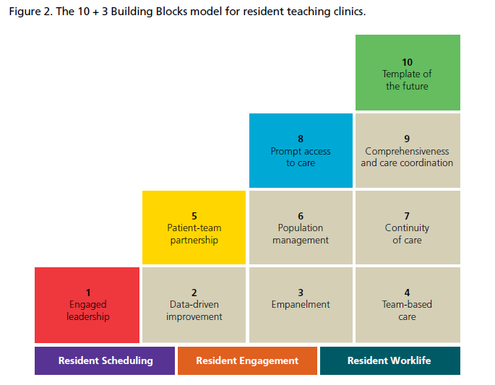

Reference:

Developed by UCSF and published by AAMC

Brown SR, Bodenheimer T, Kong M. HIGH-PERFORMING PRIMARY CARE RESIDENCY CLINICS: A COLLABORATION. Ann Fam Med. 2019 Sep;17(5):470–1. doi: 10.1370/afm.2452. PMCID: PMC7032910.